2024 Annual Report

International Geographical Union’s (IGU)

Commission C24.44 on Transport and Geography

MEMBERSHIP AND STEERING COMMITTEE
Membership
At the end of 2024, membership of the IGU Transport and Geography Commission (T&GC) totalled 427 members from 48 countries (with 61 members not specifying their country). Membership includes attendees and participants at T&GC sessions held at IGU Santiago 2011, IGC Cologne 2012, IGU Kyoto 2013, IGU Krakow 2014, IGU Moscow 2015, IGC Beijing 2016, IGU Quebec City 2018, RGS London 2019, the online workshop in 2020, IGU Istanbul 2021, the 2022 Centennial Congress in Paris, the 9th EUGEO 2023 in Barcelona, and IGC Dublin 2024, as well as Steering Committee members and colleagues who have joined through self-requests.

Since 2024, the membership subscription has been managed via the Millerite platform, which allows subscribers to directly sign up to join our mailing list. During the IGC Dublin in August 2024, we displayed a QR code during the conference sessions for membership registration. This approach proved highly effective and resulted in a significant surge in subscriptions.

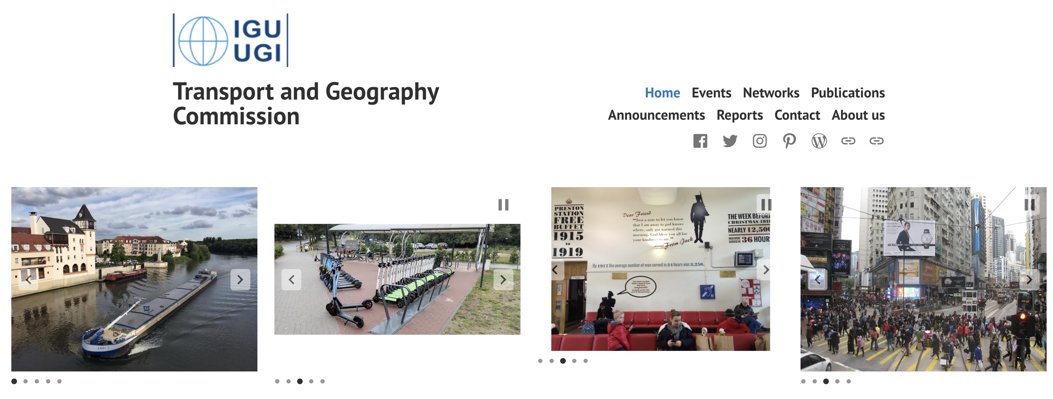
 | 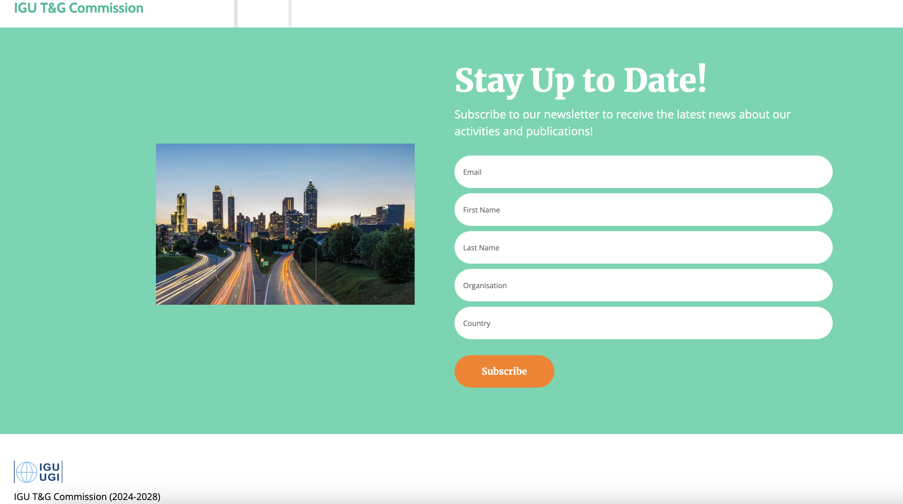

The commission Website: https://igu-transport.org/
Table 1 Breakdown of Transport and Geography Commission members by country
United States | 87 | Spain | 2
China | 39 | Trinidad and Tobago | 2
United Kingdom | 37 | Turkey | 2
Ireland | 34 | Albania | 1
France | 28 | Algeria | 1
Netherlands | 18 | Colombia | 1
Germany | 12 | Croatia | 1
Poland | 12 | Czechia | 1
Finland | 11 | Estonia | 1
Canada | 8 | Georgia | 1
Hong Kong | 8 | Hungary | 1
Japan | 6 | Iraq | 1
Australia | 5 | Ivory Coast | 1
Austria | 5 | Malaysia | 1
Belgium | 4 | Mexico | 1
India | 4 | Nigeria | 1
Sweden | 4 | Romania | 1
Malta | 3 | Saudi Arabia | 1
South Korea | 3 | Slovakia | 1
Brazil | 2 | Slovenia | 1
Ghana | 2 | Switzerland | 1
Italy | 2 | Tanzania | 1
Russia | 2 | Ukraine | 1
Singapore | 2 | Unknown | 61
South Africa | 2 | Total | 427

T&G Commission’s LinkedIn Account

In addition to communication through the website and mailing list, the T&G Commission’s LinkedIn page was officially created by the new secretary, Dr. Dong, in December 2024. This has significantly enhanced the dissemination of the Commission’s activities. At the time of writing this annual report, the number of followers has grown to 182 within just one month. | 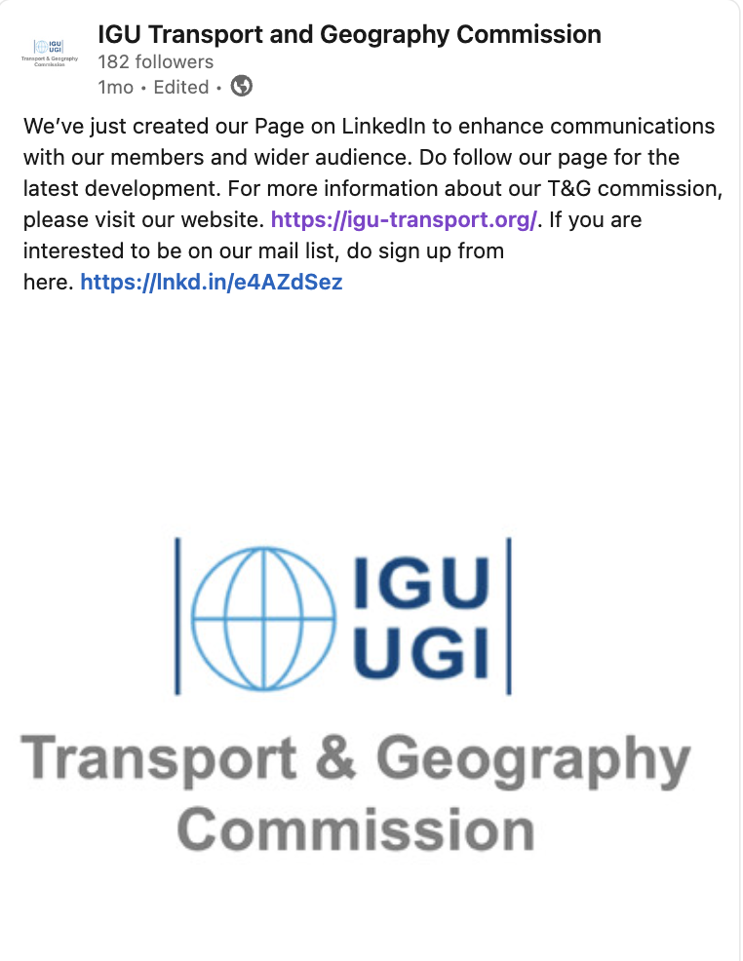
Steering Committee 2024–2028

A new Steering Committee was proposed before August 2024 and officially approved in September 2024 by the IGU Committee for the next four years. We would like to extend our gratitude to Chair Frédéric DOBRUSZKES for his excellent leadership during 2020 and 2024 and are delighted to welcome him as an honorary member alongside the founder, Prof. Richard Knowles, and Prof. Andy Goetz. This recognition serves as a heartfelt thank you for their profound contributions to the life of our Commission over the past decade.

Equally, we would like to thank Professor Claude COMTOIS, Université de Montréal, Canada; Dr Ana CONDECO-MELHORADO, Universidad Complutense de Madrid, Spain; Professor Tim RYLEY, Griffith University, Queensland, Australia; Professor Koichi TANAKA, Ibaraki University, Japan; and Professor James WANG, University of Hong Kong, Hong Kong SAR, for their valuable contributions to the Steering Committee over the past eight years (2016–2024).

Following the Business Meeting discussion at the Paris Congress in 2022, our targets for the Steering Committee from 2024 onwards are twofold:
• To improve gender equity
• To develop geographical diversity, with more members from developing countries, as highlighted by the IGU.

We are pleased to have met these goals, with four female SC members and enhanced geographical diversity, including new committee members from Australia, Brazil, Colombia, Ghana, and Turkey. A warm welcome to Dr Dorina POJANI, The University of Queensland, Australia; Professor Rafael H. M. PEREIRA, Institute for Applied Economic Research, Brazil; Professor Gordon WILMSMEIER, Los Andes University, Colombia; Dr Ernest AGYEMANG, University of Ghana, Ghana; and Dr Ela BABALIK, Middle East Technical University, Turkey, who have agreed to join the Steering Committee.

   | 
Below are the members of the new Steering Committee.

Chair
Dr Chia-Lin CHEN, University of Liverpool, UK
Senior Lecturer in Department of Geography and Planning
chia-lin.chen@liverpool.ac.uk

Vice Chair
Professor Pengjun ZHAO
Peking University, Beijing, China
Department of Urban and Regional Planning
pengjun.zhao@pku.edu.cn

Secretary
Dr Dong LIU
Research Assistant Professor, The Chinese University of Hong Kong, Hong Kong SAR
dongliu@cuhk.edu.hk
Treasurer ex officio (honorary member):
Professor Andrew Goetz, University of Denver, Colorado, USA
agoetz@du.edu

Honorary members
- (Founder) Professor Richard KNOWLES, University of Salford, UK & University of Huddersfield, UK
R.D.Knowles@salford.ac.uk
- Professor Andrew GOETZ, University of Denver, Colorado, USA
andy.goetz@du.edu
- Professor Frédéric DOBRUSZKES, Brussels Free University ULB, Belgium
frederic.dobruszkes@ulb.be
Other members
- Dr Ernest AGYEMANG, University of Ghana, Ghana
eagyemang@ug.edu.gh
- Dr Ela BABALIK, Middle East Technical University, Turkey
ela.babalik.1@gmail.com
- Professor Julie CIDELL, University of Illinois, USA
jcidell@illinois.edu
- Professor Rafael H. M. PEREIRA, Institute for Applied Economic Research, Brazil
rafael.pereira@ipea.gov.br
- Dr Dorina POJANI, The University of Queensland, Australia
d.pojani@uq.edu.au
- Professor Aisling REYNOLDS-FEIGHAN, University College Dublin, Ireland
aisling.reynolds@ucd.ie
- Professor Thomas THEVENIN, University of Bourgogne, Franche Comte, France
Thomas.Thevenin@u-bourgogne.fr
- Professor Gordon WILMSMEIER, Los Andes University, Colombia
g.wilmsmeier@uniandes.edu.co

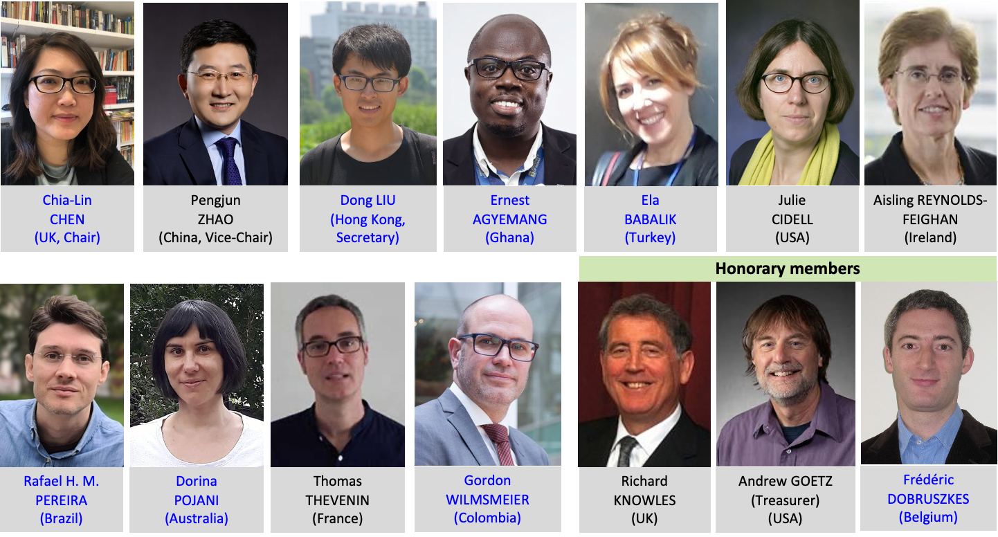
Figure 1 Steering Committee of the T&G Commission 2024-2028

NEW INITIATIVES: Online Workshops
The Commission initiated an online workshop series in Autumn 2024, with three online workshops planned per year, in principle. Steering Committee members and all other members are encouraged to propose workshop sessions on topics of their interest, facilitating global participation. For the first year (August 2024–August 2025), three workshop topics have been identified: Transport Geography Research in and on Africa, Recent Trends in Publishing, and Geography of Maritime Transport. These workshops are being organised by Dr Ernest AGYEMANG (with Professor Frédéric DOBRUSZKES), Professor Rafael H. M. PEREIRA, and Professor Gordon WILMSMEIER, respectively.

The first workshop, Transport Geography Research in and on Africa, will take place on 22nd January 2025, 12:00–14:00 GMT. Details of the other two workshops will be announced in due course.

Below is a poster for the first online workshop. For more details, please refer to the website.
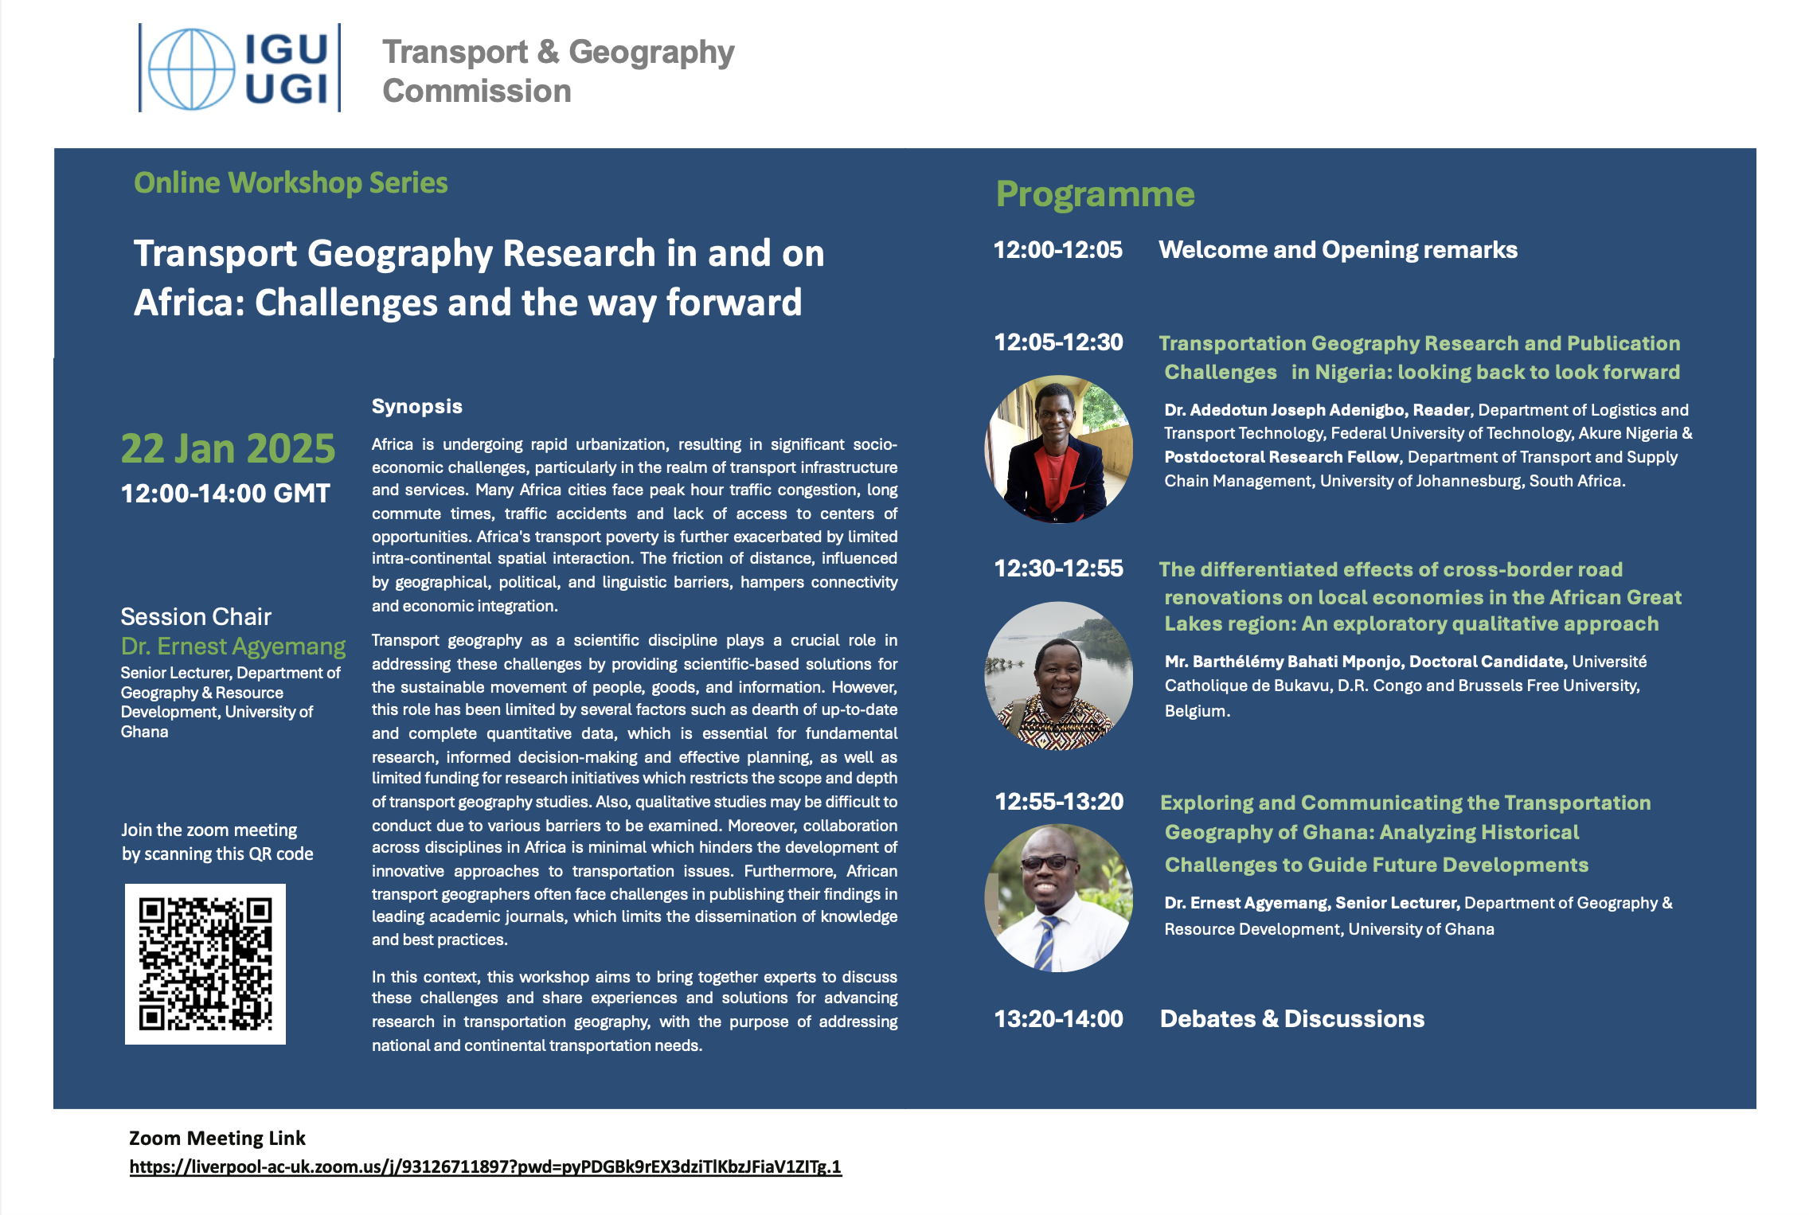

CALL FOR SESSIONS: 10TH EUGEO 2025, VIENNA AUSTRIA 8-11 SEPTEMBER
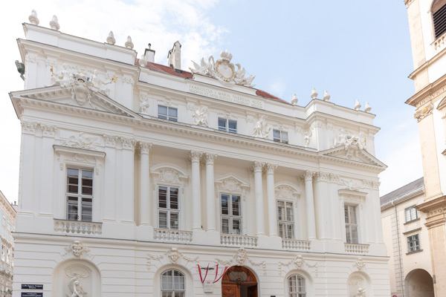

Preparing 10th EUGEO Congress, September 2024
The Transport & Geography Commission has been active in organising call for papers to the 10th EUGEO Congress held in Vienna, Austria (8-11 Sept 2025), with three sponsored sessions as follows. The call for abstracts is due on 20 January 2025.

Session ID | Session Title | Conveners
115 | The changing and contrasting geographies of railways in Europe | Simon Blainey, Amparo Moyano
116 | Quantitative approaches for disabled mobility studies: Rationale, issues, pitfalls and results | Enka Blanchard, Frédéric Dobruszkes
117 | Transborder and cross-border transportation: Connectivity, accessibility, and mobility | Chia-Lin Chen, Jie Huang, Jiaoe Wang

The FIRST ONLINE MEETING for STEERTING COMMITTEE MEMBERS
The newly appointed Steering Committee (SC) of the IGU Transport and Geography Commission for the 2024-2028 term held its inaugural online meeting on 9th October 2024. Chaired by Dr Chia-Lin CHEN, this significant meeting brought together both returning and new SC members for introductions and an exchange of ideas.

The meeting enabled SC members to familiarise themselves with the core mission and objectives of the T&G Commission and begin brainstorming future activities and initiatives for the next four years. In addition to IGU and non-IGU conferences, the Steering Committee welcomes the proposal to introduce online thematic seminars, which will be held three times a year. Drawing on the diverse expertise and interests of our SC members, the T&G Commission will explore a broad range of topics, including new trends in publishing, transport geography across different countries, methodological debates in the field, gender equity in transport geography research, and more. A list of topics for the first year, and beyond, will be developed and announced once finalised.

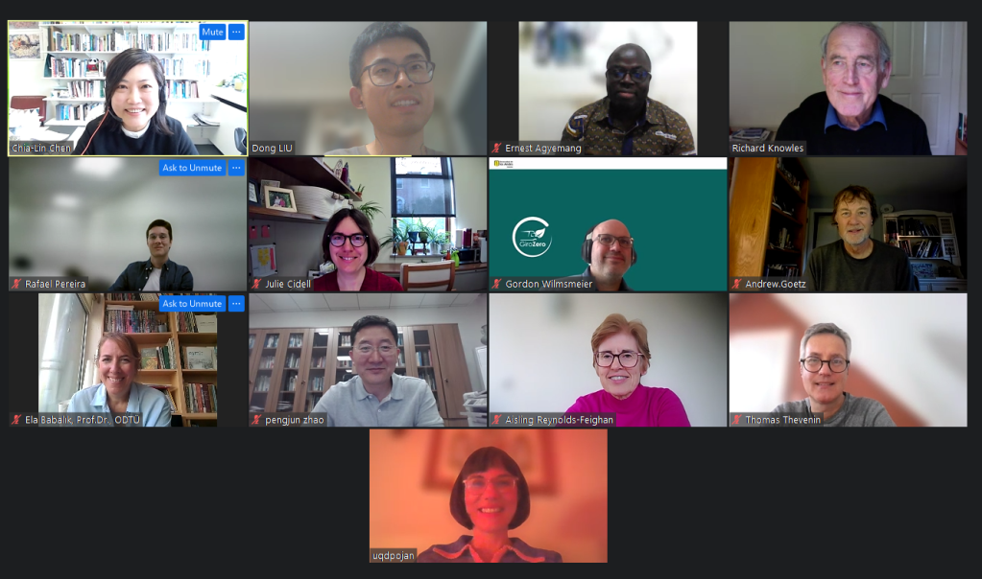

The 35th IGC DUBLIN CONGRESS AND ACTIVTIIES


The Transport and Geography Commission held a successful and dynamic conference at DCU Dublin. The event featured a wide range of interesting and important topics, with engaging discussions throughout. It was a fantastic opportunity to learn, connect, and collaborate within our community. In total, there were 13 themed sessions consisted of 26 slots, 97 oral papers and 1 poster. A big thank you to all the presenters, session proposers, and chairs for making sessions below so interesting and engaging!

The sessions cover the below titles.
- Emerging opportunities and challenges for transport equity in a rapidly digitalized world and New trends of rural transport and rural sustainability (chaired by Prof. Pengjun Zhao).
- Geographies of air transport (chaired by Prof. Andy Goetz)
- Geographies of high-speed rail (chaired by Dr Chia-Lin Chen & Prof. Andy Goetz)
- In the wake of social and technological transformation: Revisiting the future of mobility (chaired by Dr Matthias Sweet & Prof. Darren Scott)
- Medium-sized, small, peripheral ports and territorial development (chaired by Dr Arnaud Serry)
- Progress in shared mobility research (chaired by Dr Ana Condeço Melhorado Condeço)
- Re-making of space through urban experiments (chaired by Dr Kristina Trygg & Dr Ida Grundel)
- Road, Rail, Tram – Geographies of Mobility (chaired by Dr Jakub Taczanowski)
- Safe or mobile? Navigating climate and mobility transitions (chaired by Prof. Nacima Baron, Prof. John Renne, Prof. Billy Fields)
- Sustainable Transit-Oriented Development (STOD): New Perspectives and Advances (chaired by Dr Chia-Lin Chen; Prof. Richard D. Knowles)
- Transportation networks over the long run (chaired by Dr Alexis Litvine, Prof. Thomas Thévenin)

For more detail of the papers, please find from our commission website or here.

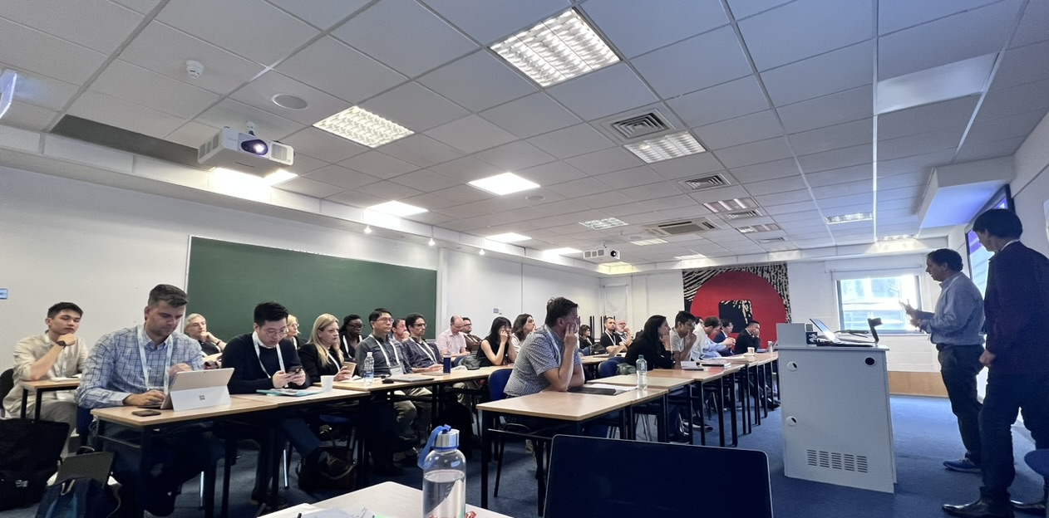 | 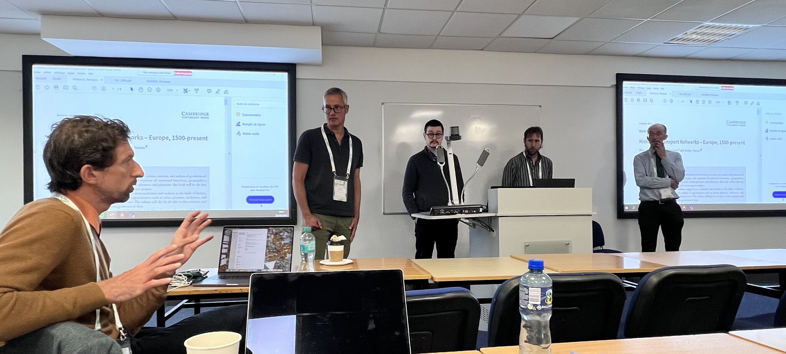
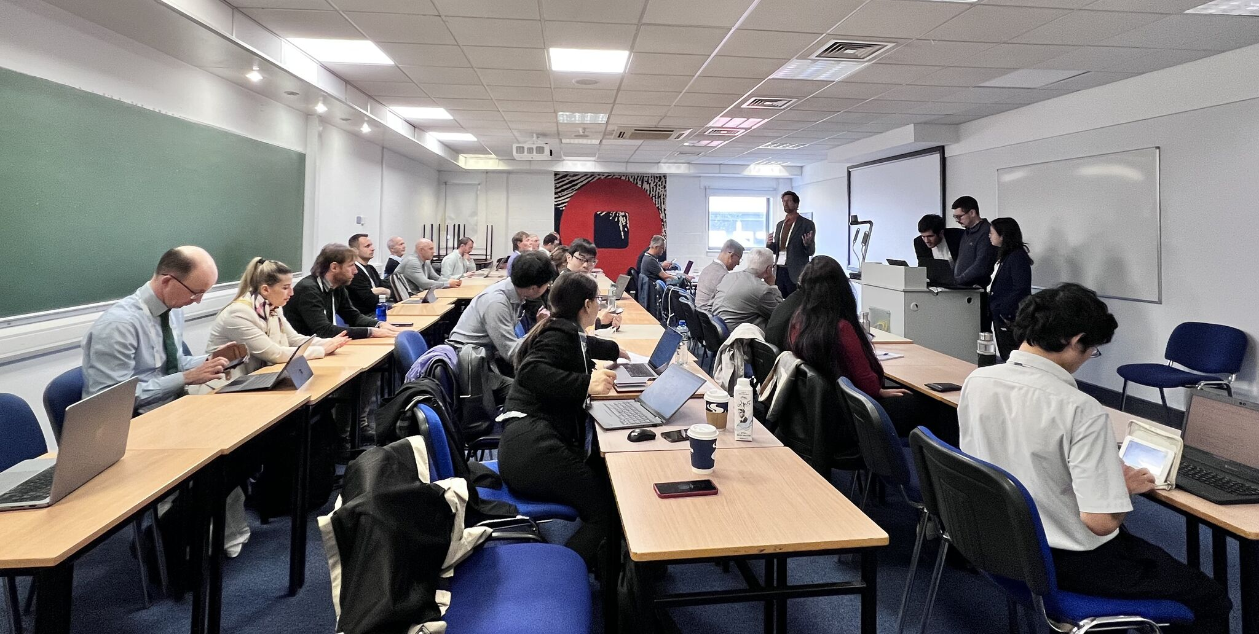 | 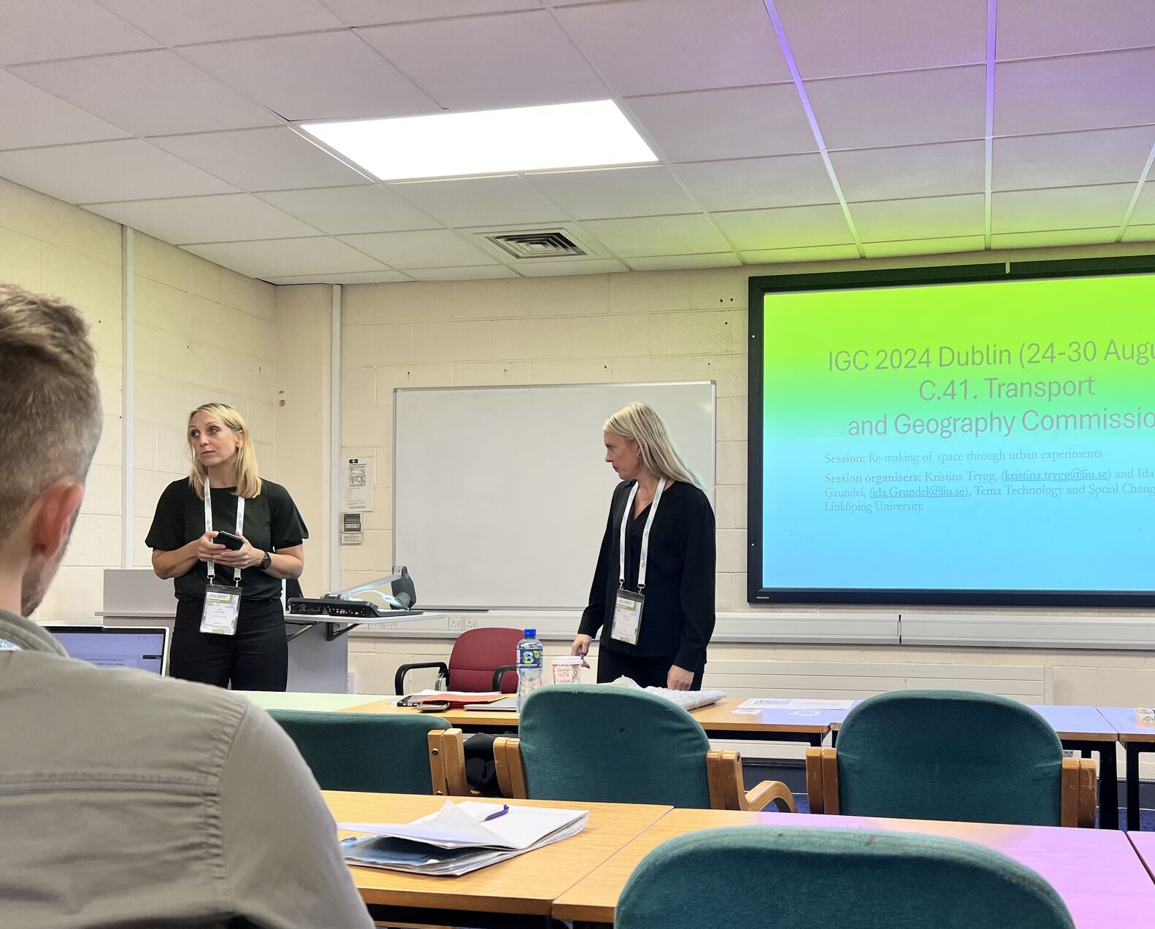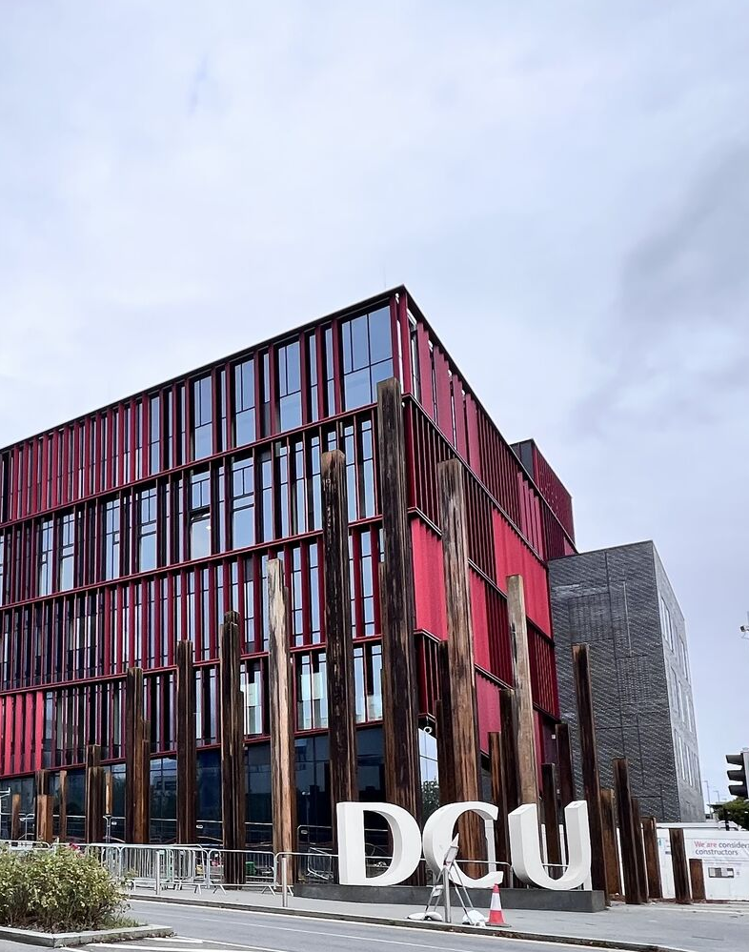
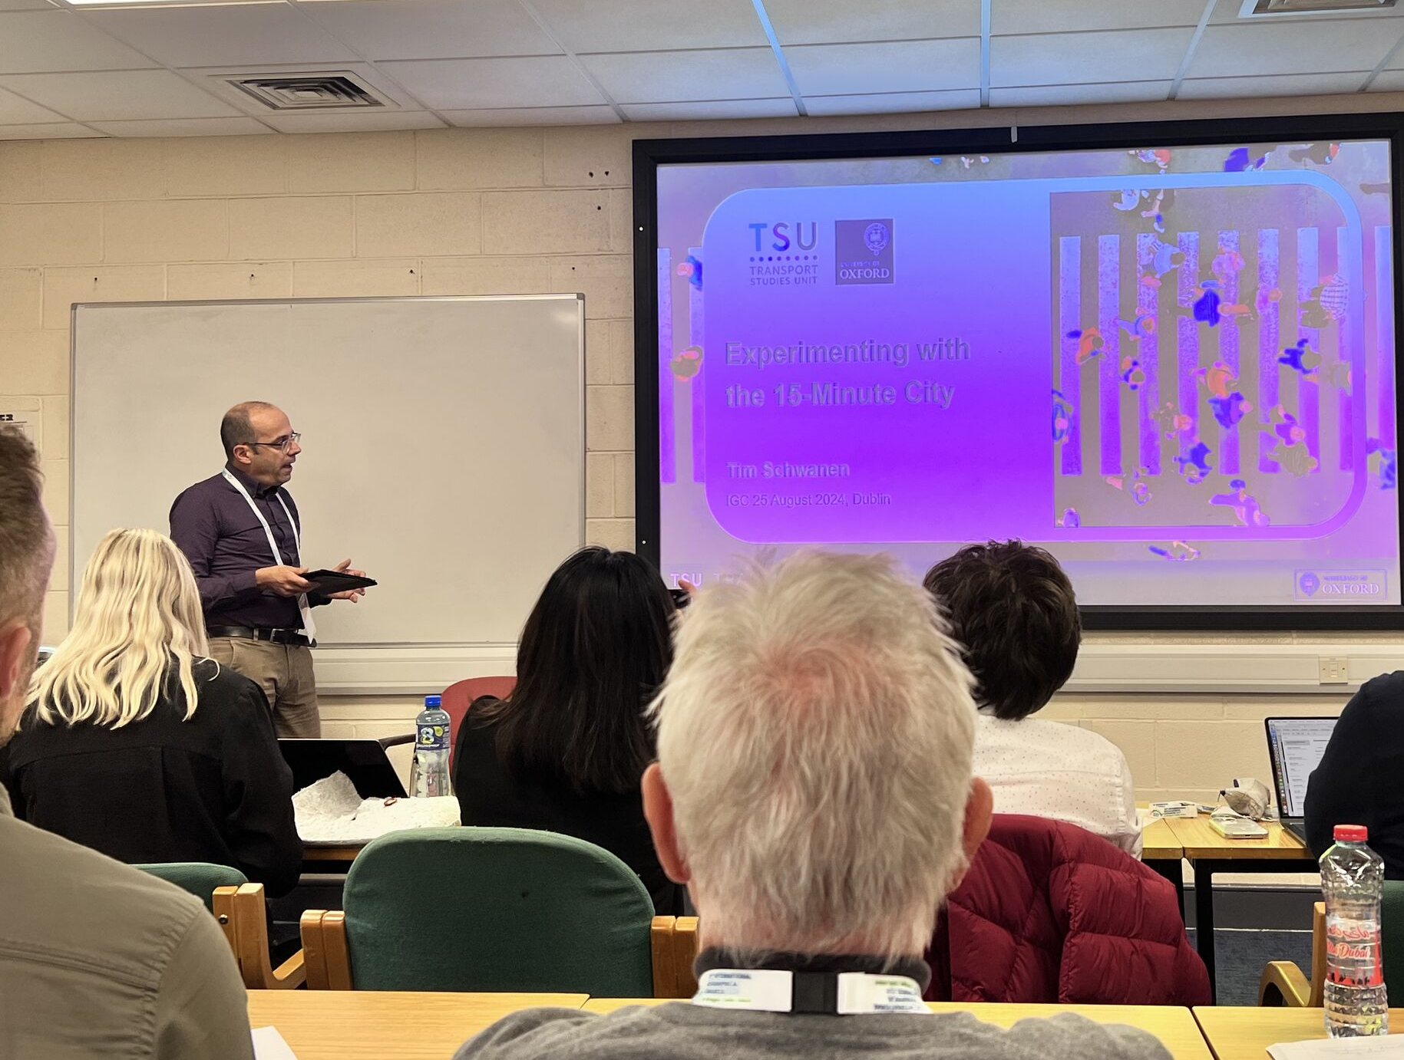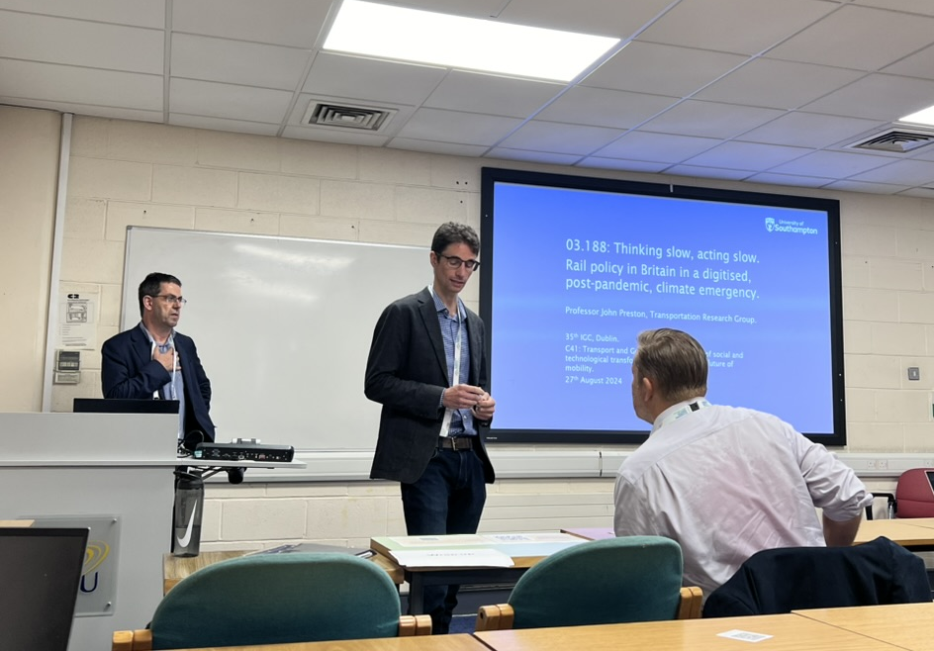 | 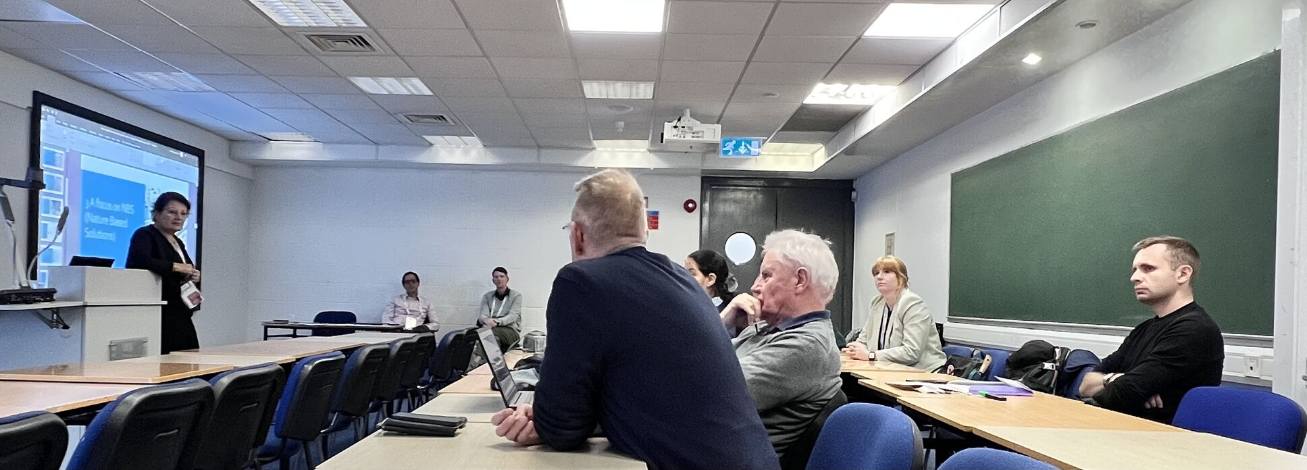
Figure 2 Snapshots of the scenes during the conference

Informal Social Event
An informal social event was organised on 27 August Tuesday from 6:30pm at The Ivy House (https://www.theivyhouse.ie/ to allow further exchanges and networking among participants). The T&G Commission would especially thank Professor Aisling Reynolds for her excellent arrangement of finding the venue and sponsorship for this event.

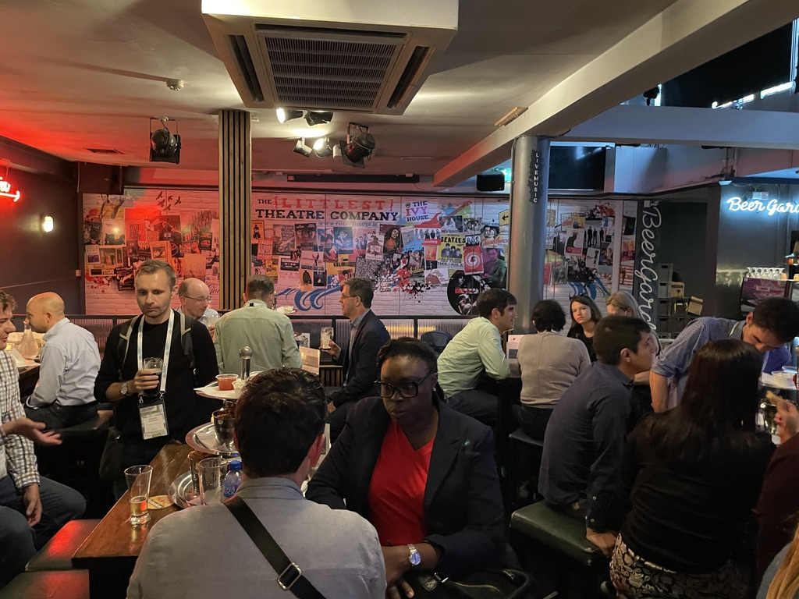 | 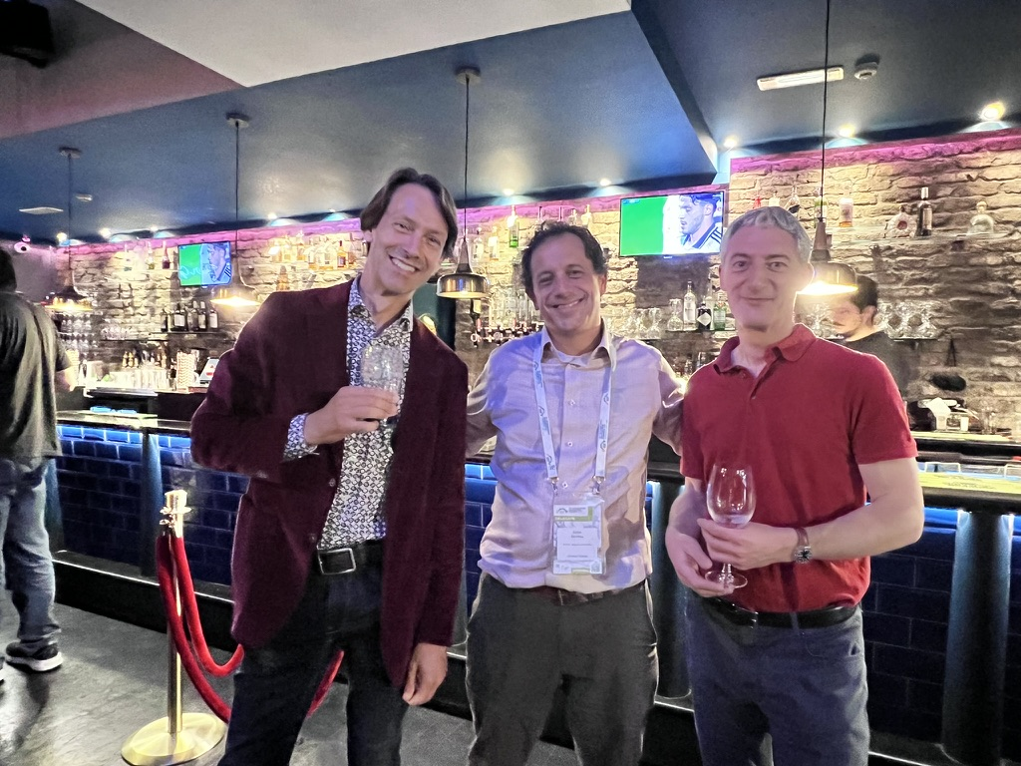 | 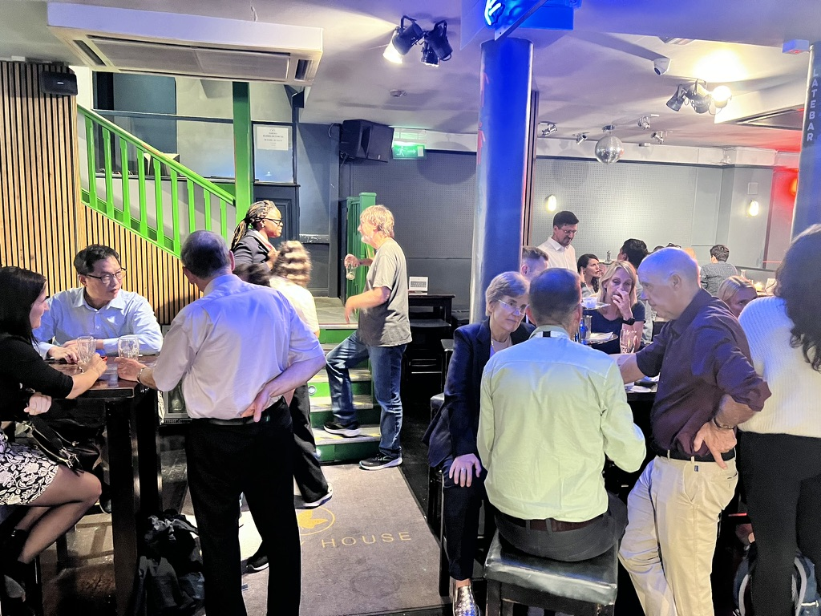
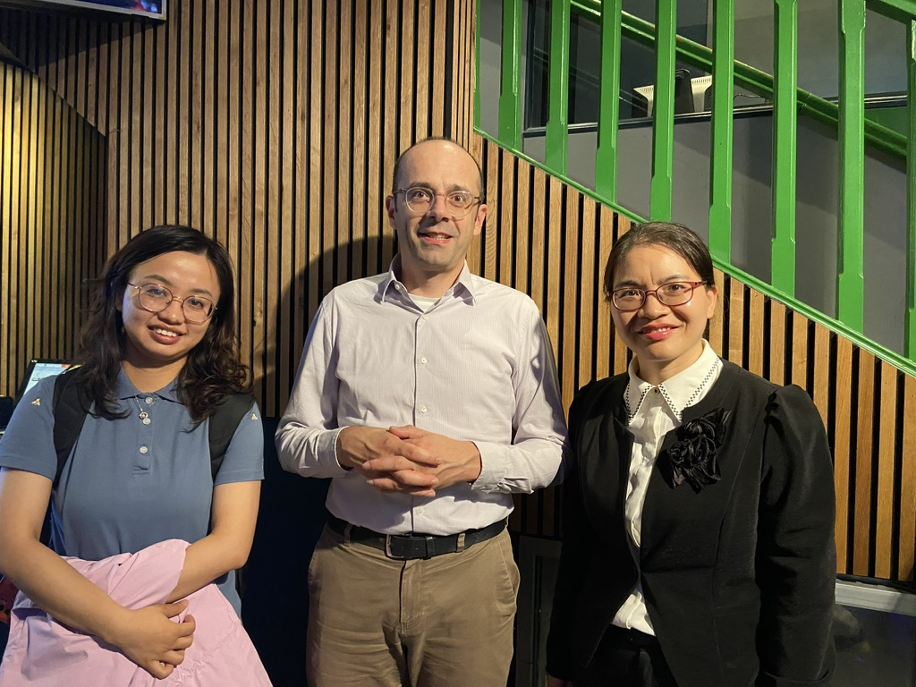 | 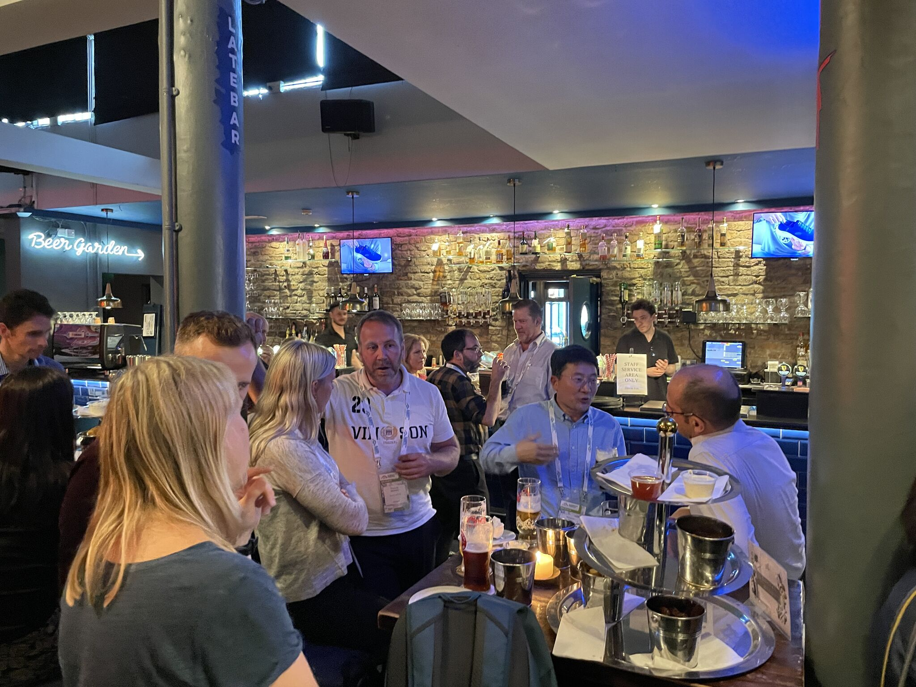 | 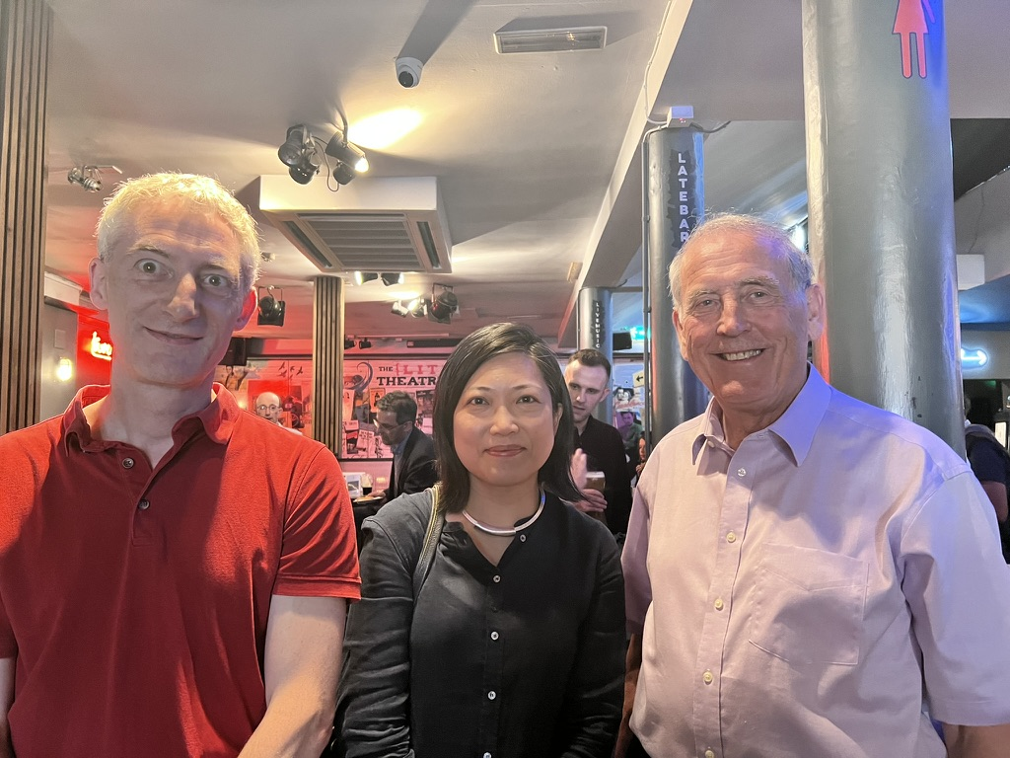
Figure 3 Snapshots of the scenes during the social event

The business meeting
The commission’s business meeting was held on Tuesday 27 Aug, 13-14 at Business School Q120 at DCU. The business meeting was a success, with a strong turnout. The commission business meeting covered a range of items as shown below.
- Steering Committee
- Commission membership
- Reviewing 2023/2024 main activities
- T&G Commission Travel Grants giving (by A. Goetz)
- Perspectives for 2025 onwards
- Book Series: Transport, Mobilities & Spatial Change (by R. Knowles)
- Any other business
- Address by the new Chair

Congratulations to Katherine Agong (University of the West Indies, Trinidad) and Dmitry Boyko (Researcher at Leibniz Universität Hannover) for receiving travel grant awards.
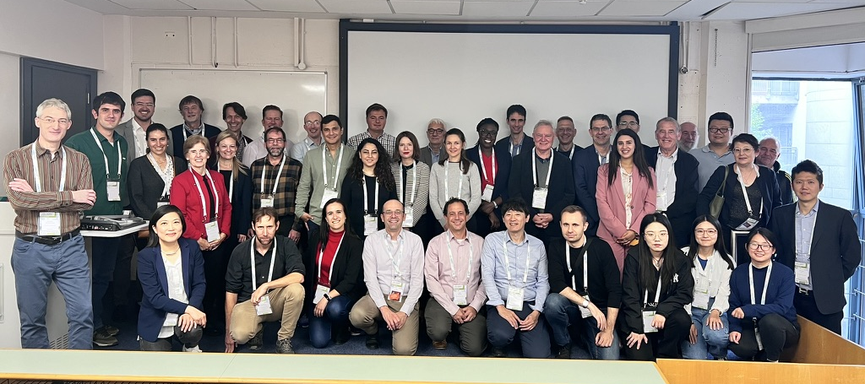
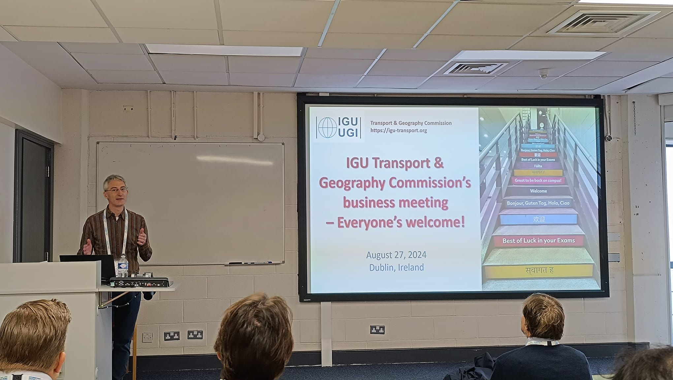 | 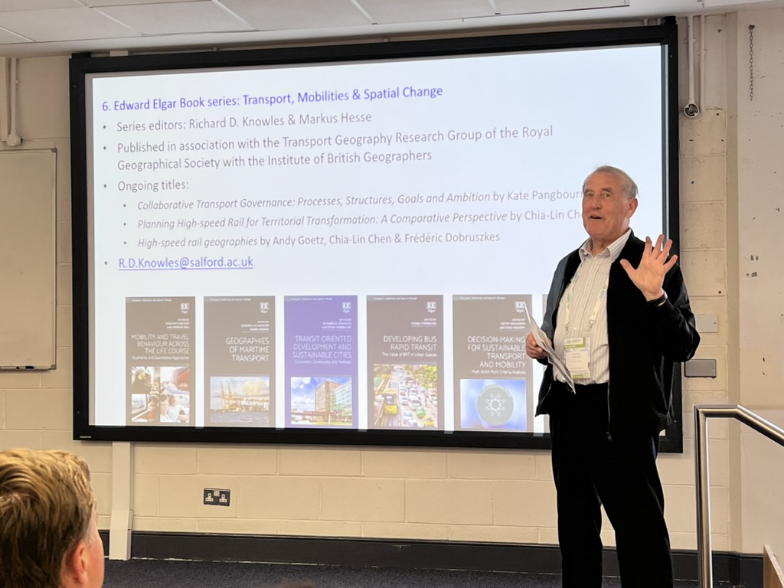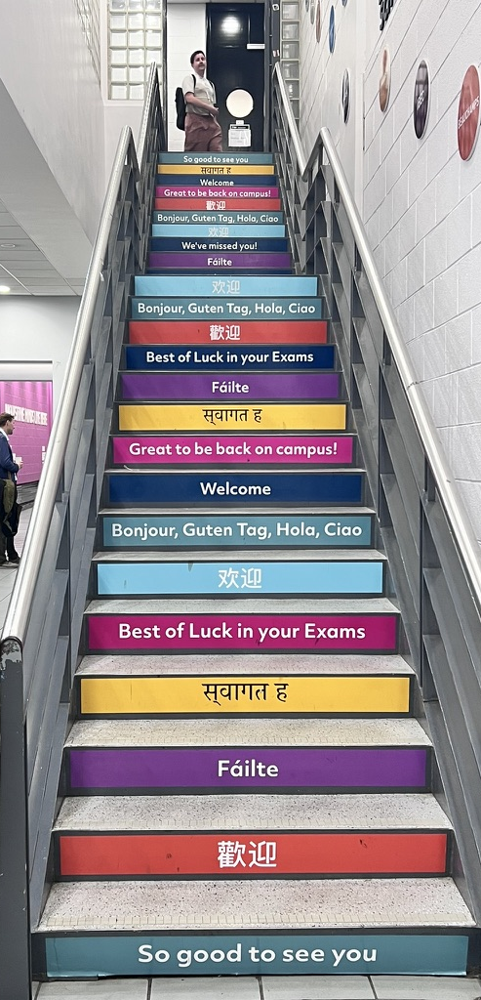
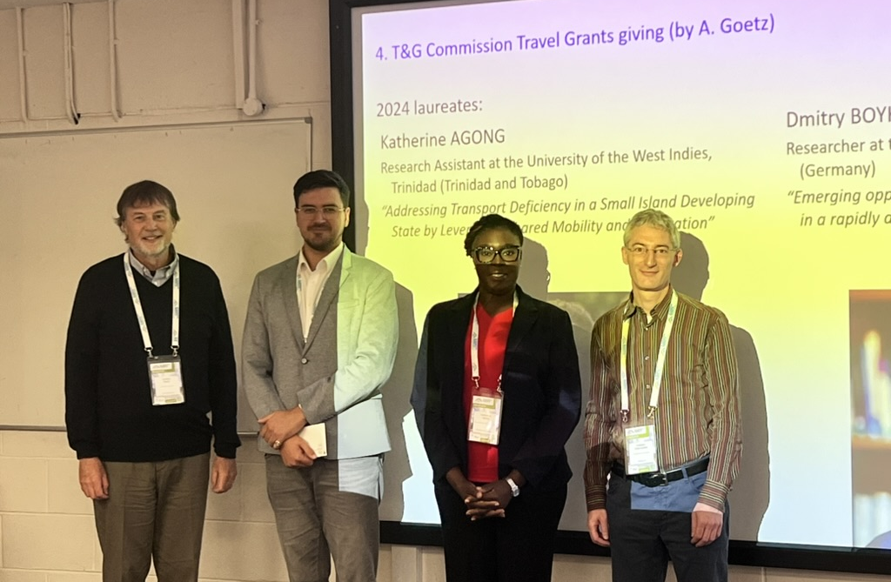 | 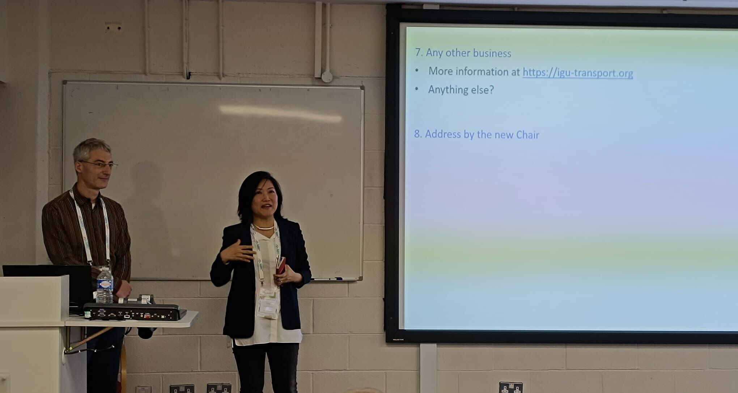
Figure 4 Snapshots of the scenes during the business meeting

Overall, the success of our sessions, business meeting, and informal social events confirmed the value and rationale for in-person events.

NETWORKING
The mission of the IGU Transport and Geography Commission is to share and disseminate transport geography research at a global level in conjunction with national research groups and other IGU Commissions. Our research focuses on transport, mobilities and spatial change and relates to geographic theory. It involves the analysis of transport policies, processes and behaviours that influence the movement of people, goods and information. This research includes all modes of transport, at local, regional and global scales. Environmental, welfare and energy questions, and social, economic and governance dimensions are also addressed. Dissemination of the Commission’s work includes books, research journal papers and journal Special Issues.

As a result, the Commission liaises other transport research groups and other IGU Commissions including:
- the Transportation Geography Specialty Group (TGSG) of the American Association of Geographers
- the Hong Kong Society for Transportation Studies (HKSTS)
- the Transport Geography Research Group (TGRG) of the Royal Geographical Society (with the Institute of British Geographers)
- AK Mobilitat und Verkehr (Germany)
- NECTAR (Network on European Communications and Transport Activity Research)
- EUGEO (Association of Geographical Societies in Europe).
- IGU Commission on Urban Geography
- IGU Commission on Geography of Tourism, Leisure, and Global Change

T&GC Steering Committee members and many ordinary Commission members have strong international links, joint research and publications with many other geographers and transport researchers.

In the first online meeting among members in the new steering committee 2024-2028, there was a strong interest through the new committee members to extend our transport geography networks to Africa, South America and other parts of the world. Meanwhile, the commission welcomes and encourages continual collaboration in the organisation of joint special session with other commissions in future events and conferences.

PUBLICATIONS
Several papers presented at the aforementioned themed sessions in the International Geographical Congress (IGU) at Dublin in August 2024 would be/have been submitted to (and some already been published in academic journals.

A few sessions organised are associated with one book project, entitled “Historical Transport Networks Europe 1500-Present” and two special issues, namely the journal “Cities” on the topic entitled “Sustainable Transit-Oriented Development (STOD): New perspectives and Advances” and “Built Environment” on the topic "Navigating climate and mobility transitions".

ARCHIVAL CONTRIBUTIONS

[For the record]

PRODUCTIVE USE OF PREVIOUS IGU GRANT LIKE SUPPORTING YOUNG SCHOLARS, PUBLICATIONS AND SEMINARS FROM LOW INCOME COUNTRIES
The commission is pleased to award Katherine Agong (University of the West Indies, Trinidad) and Dmitry Boyko (Researcher at Leibniz Universität Hannover) for receiving travel grant awards.

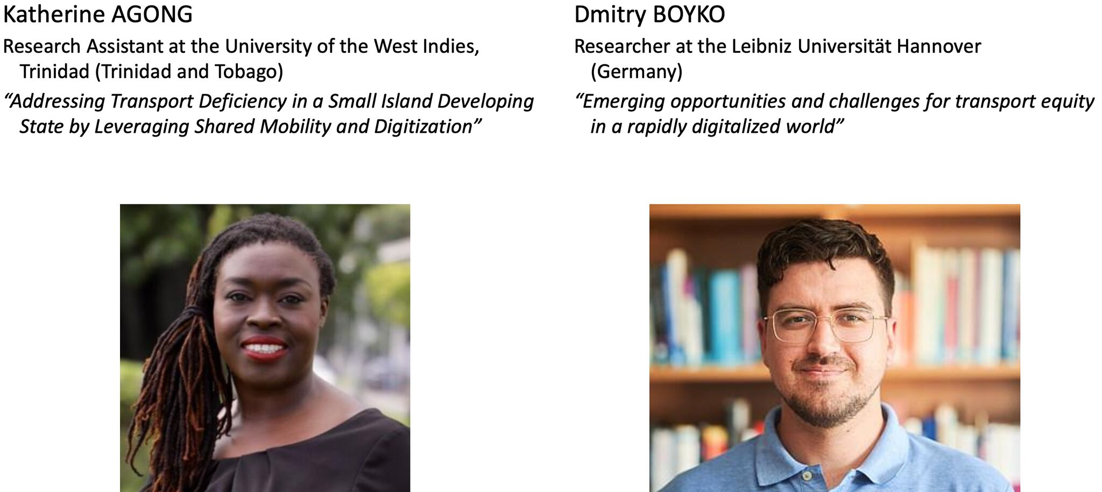

Dr Chia-Lin CHEN(Chair)
chia-lin.chen@liverpool.ac.uk

Professor Pengjun ZHAO (Vice-Chair)
pengjun.zhao@pku.edu.cn

Dr Dong Liu (Secretary)
dongliu@cuhk.edu.hk

17 January 2025

