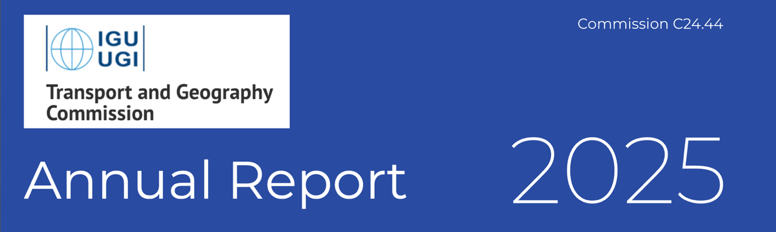

December 2025

Membership

- Commission Steering Committee (2024-2028)
The composition of the current Steering Committee improves gender equity and geographical diversity, including increased representation from developing countries (Brazil, Colombia, Ghana and Turkey) and five female SC members.

Chair
Dr Chia-Lin CHEN
Senior Lecturer at Department of Geography and Planning
School of Environmental Sciences
Roxby Building, Room 315
University of Liverpool, Liverpool
United Kingdom
Email: chia-lin.chen@liverpool.ac.uk phone: +44-0151 795 1708

Vice Chair
Professor Pengjun ZHAO
Professor and Dean of the School of Urban Planning and Design
School of Urban and Environmental Sciences
Peking University, Beijing, China
Email pengjun.zhao@pku.edu.cn

Secretary
Dr Dong LIU
Assistant Professor in Division of Computational Social Science
School of Humanities and Social Science
The Chinese University of Hong Kong, Shenzhen (from 15 January 2025, originally Chinese University of Hong Kong, Hong Kong SAR)
E-mail: dongliu@cuhk.edu.cn

Treasurer (ex officio)
Professor Andrew Goetz
Department of Geography
University of Denver
United States of America
E-mail: agoetz@du.edu

List of Transport and Geography Commission Steering Committee Members

Australia | Dr Dorina POJANI  The University of Queensland, Australia  d.pojani@uq.edu.au | Ireland | Professor Aisling REYNOLDS-FEIGHAN  University College Dublin, Ireland  aisling.reynolds@ucd.ie
Brazil | Professor Rafael H. M. PEREIRA  Institute for Applied Economic Research, Brazil  rafael.pereira@ipea.gov.br | Turkey | Professor Ela BABALIK  Middle East Technical University  ela.babalik.1@gmail.com
China | Professor Pengjun ZHAO  Peking University, Beijing, China  pengjun.zhao@pku.edu.cn | United Kingdom | Dr Chia-Lin CHEN  University of Liverpool  chia-lin.chen@liverpool.ac.uk
 | Dr Dong LIU  The Chinese University of Hong Kong, Shenzhen  (from 15 January 2025)  dongliu@cuhk.edu.cn | United States | Professor Julie CIDELL  University of Illinois,  jcidell@illinois.edu
Columbia | Professor Gordon WILMSMEIER  Los Andes University, Colombia  g.wilmsmeier@uniandes.edu.co | Honorary  members | Professor Richard KNOWLES (Founder)  University of Salford, UK & University of Huddersfield, UK R.D.Knowles@salford.ac.uk
France | Professor Thomas THEVENIN  University of Bourgogne, Franche Comte  Thomas.Thevenin@u-bourgogne.fr |  | Professor Andrew GOETZ  University of Denver, Colorado, USA  andy.goetz@du.edu
Ghana | Dr Ernest AGYEMANG  University of Ghana, Ghana  eagyemang@ug.edu.gh |  | Professor Frédéric DOBRUSZKES  Brussels Free University ULB, Belgium  frederic.dobruszkes@ulb.be
Hong Kong SAR | Dr Dong LIU  Chinese University of Hong Kong, Hong Kong SAR (before 15 January 2025)

- Commission members /participants

At the time of December 2025, the IGU Transport and Geography Commission totalled 354 members from 43 countries (with 25 members not specifying their country). This current membership contains the most up-to-date records of members who have registered with an email address, enabling direct communication.

Founded in 2009, the commission expanded its membership through attendees and participants at various T&GC sessions, including those held at IGU Santiago 2011, IGC Cologne 2012, IGU Kyoto 2013, IGU Krakow 2014, IGU Moscow 2015, IGC Beijing 2016, IGU Quebec City 2018, RGS London 2019, IGC Centennial Congress Paris 2022, EUGEO Barcelona 2023, IGC Dublin 2024, EUGEO Vienna 2025, RGS Birmingham 2025. From 2024, additional members have also joined through the online self-subscription form available on the commission website.

Breakdown of commission members by country:
United States | 71 | Canada | 6 | Russia | 2 | Colombia | 1
China | 49 | Austria | 5 | Italy | 2 | Slovenia | 1
United Kingdom | 33 | Spain | 4 | Sweden | 2 | Saudi Arabia | 1
Ireland | 22 | India | 4 | Belgium | 2 | Slovakia | 1
France | 19 | Singapore | 3 | Georgia | 1 | Czechia | 1
Netherlands | 18 | Ghana | 3 | Algeria | 1 | Argentina | 1
Germany | 16 | Malta | 3 | Ivory Coast | 1 | South Africa | 1
Poland | 12 | Mexico | 2 | Ukraine | 1 | Hungary | 1
Australia | 7 | Brazil | 2 | Croatia | 1 | Nigeria | 1
Hong Kong | 7 | Turkey | 2 | Morocco | 1 | Unknown | 25
Japan | 6 | South Korea | 2 | Malaysia | 1
Finland | 6 | Trinidad and Tobago | 2 | Iraq | 1 | TOTAL | 354

Meetings

- Online workshop: “Transport Geography Research in and on Africa”
22 January 2025 (Participants: APPROX. 20)

Organised by Steering Committee member Dr Ernest Agyemang, this online workshop focused on transport geography research in and on Africa, with a strong emphasis on Global South engagement and capacity building. Three invited speakers — Dr Adedotun Joseph Adenigbo (Nigeria), Mr Barthélémy Bahati Mponjo (DR Congo/Belgium), and Dr Ernest Agyemang (Ghana) — facilitated in-depth discussion on research challenges, publication pathways, and policy-relevant issues, fostering inclusive international knowledge exchange. | 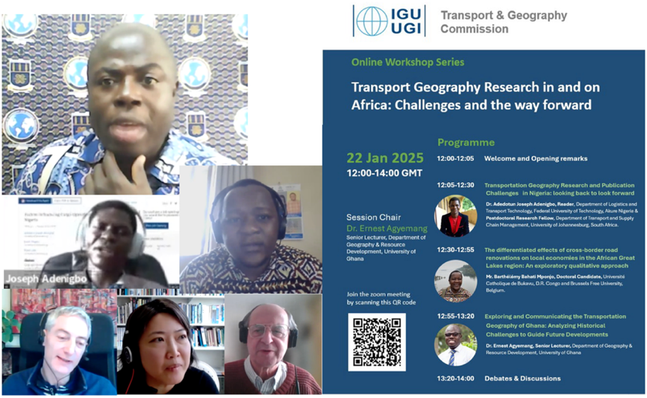
- RGS-IBG Annual International Conference, Birmingham, UK, 28 Aug 2025
The commission endorsed one themed session (2 slots / 10 papers), entitled ‘Rethinking Transit-Oriented Development: Integration, Equity, Strategic Planning and Investment”, co-convened by Dr Chia-Lin Chen and Professor Richard Knowles. Subsequently, the session was successfully approved for development into a special issue on the Journal of Transport Geography (Submission period: 1 December 2025 - 31 May 2026).

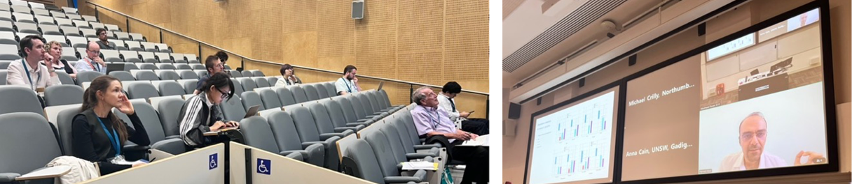

- Online workshop: “Moving Forward – Understanding Women’s Realities in Urban Transport” 3 September 2025 (Participants: APPROX. 25)
Organised by Steering Committee member Dr Dorina Pojani, this online workshop examined women’s lived experiences of urban mobility, safety, and accessibility. The programme featured three invited speakers from Australia— Dr Dorina Pojani, Dr Nicole Kalms, and Professor Kurt Iveson— allowing for in-depth discussion of gender-sensitive perspectives and inclusive

approaches in urban transport research and planning.  The discussions were further enriched by participants’ shared experiences from India, Africa and other regions, with contributions from scholars affiliated with institutions in countries including the UK, Norway, France. | 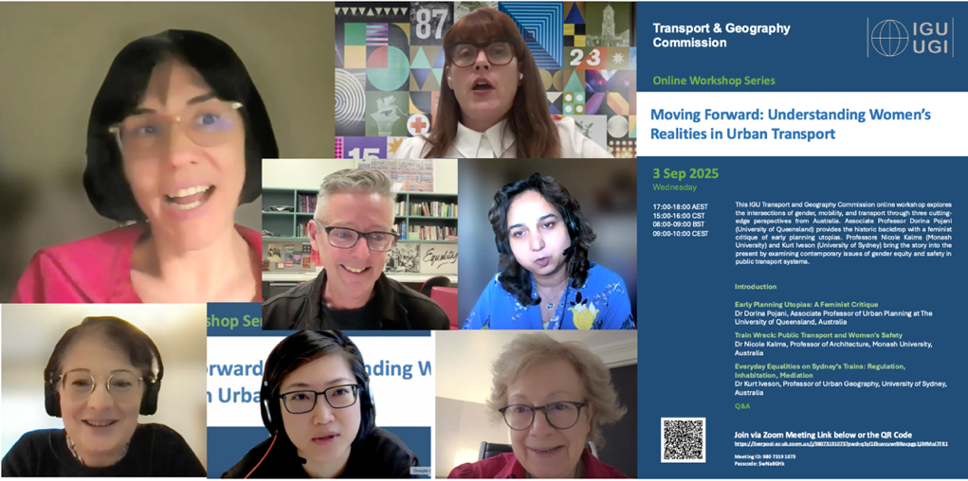

- 10th EUGEO 2025 Vienna, Austria, 8-11 September 2025
The commission organised and endorsed 3 themed sessions (5 slots / 19 papers) at this conference, including 115: The changing and contrasting geographies of railways in Europe; 116: Quantitative approaches for disabled mobility studies: Rationale, issues, pitfalls and results, & 117: Transborder and Cross-border Transportation: Connectivity, Accessibility, and Mobility, co-convened. An informal social event was organised on Tuesday 9 September, from 18:30 at Die Schankwirtschaft pub in the Augarten Park. The T&G Commission would like to express its special thanks to Professor Frédéric DOBRUSZKES for his excellent organisation in identifying and booking the venue.
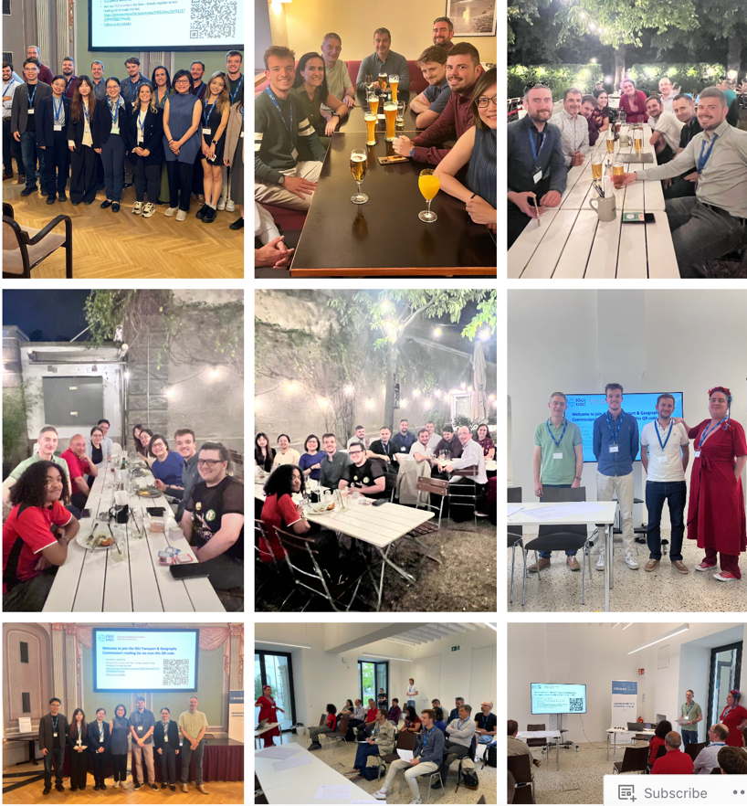

- Annual Steering Committee Meeting (Online), 26 November 2025
The annual meeting of the IGU Transport & Geography Commission Steering Committee was held online on 26 November 2025 to review the Commission’s activities and governance matters for the year. Key discussions include progress in gender balance and global representation; the Commission’s financial position and the strategic use of funds to support early career researchers’ travel grants; Approval of a new travel support policy for Steering Committee members affiliated with institutes in low- and lower-middle-income countries; Updates to the travel grant support for early-career participants (increase in the funding amount); Ongoing efforts to secure hybrid sessions at IGU meetings to widen the participation, particularly for the IGC Melbourne in 2028; and Initiatives to support early-career and young researchers at the IRC Istanbul 2026, including conference side events and field-based knowledge exchange activities.

- IGU International Regional Conference IRC Istanbul, 17-21 August 2026
The IGU Transport and Geography Commission are organising sessions at the IRC Istanbul in 2026 and work closely with Professor Ela Babalik, Steering Committee member presenting Turky on organising a special fieldtrip exploring urban transport systems during the IRC Istanbul. This session is entitled “Learning from Istanbul: A Field Trip Exploring Urban Transport Systems—Achievements and Challenges”. 11 themed sessions are listed as below.
- Harnessing Multi-Source Spatial Big Data & GeoAI: Advancing Mobility, Health, and Sustainability in Urban Futures (Dong Liu, Jiaoe Wang & Zihan Kan)
- Towards Regional Integration: Ports and Corridors of Cross-Border Transport
(JIE HUANG, Chia-Lin Chen & Arnaud Serry)
- Advancing the 15-Minute City and Transport Geography Research Through Perspectives of scales (Chia-Lin Chen & Nacima Baron)
- Modelling Mobility Behaviours: Diverse Methods, Shared Challenges, New Insights (Louisette Garcin)
- Revisiting the Future of Mobility: Are We Really Experiencing Social and Technological Transformation? (Matthias Sweet & Darren Scott)
- Transport Shaping Space at Local, National and Global Levels (Richard Knowles & Chia-Lin Chen)
- Towards a Green and Safe Arctic Shipping Corridor (Pengjun Zhao, Caixia Zhang, Tingting Kang & Tianyu Ma)
- Transport Geography in Africa: Infrastructure, Mobility, and Social Transformation (Jiaoe Wang, Ernest Agyemang, Tebarek Lika Megento & JIE HUANG)
- Geographies of High-Speed Rail (Andrew Goetz)
- Transport Governance Across Contexts: Insights from Africa and Beyond
( Thomas Kolawole Ojo, Gladys Nyachieo, Adeniyi Oluwakoya, Chris Bic Byaruhanga, Marcelo Blumenfeld & Meleckidzedeck Khayesi)
- Resilience and Adaptability of Transport and Mobility Systems in the Face of External Shocks
( Tomasz Komornicki, Piotr Rosik & Szymon Wiśniewski)

- Future online workshops in 2026 under organisation
- March 2026: Recent Trends in Publishing (working title): Steering committee member Professor Rafael H. M. PEREIRA is organising this workshop with Tim Schwanen (Oxford) and Rachel Franklin (Harvard) as potential speakers.
- June 2026: Steering committee member Professor Gordon WILMSMEIER expressed his interest in hosting a workshop on ports or electromobility.
- October 2026: The topic and organiser for the 3rd workshop in 2026 will be finalised in due course.

Networking

The Commission has developed strong links with various research groups and IGU Commissions over the years. Two highlights can be made in 2025. Firstly, the Commission closely supported the ​3rd International Symposium on Transport Geography held in Wuhu, China (16-18 May 2025) that is led by with the Geographical Society of China Economic Geography Research Group and co-hosted by School of Geography and Tourism, Anhui Normal University as well as Institute of Geographic Sciences and Natural Resources Chinese Academy of Sciences (CAS). The Steering Committee members— Dr Chia-Lin Chen​ (Chair), Professor Pengjun Zhao (Vice Chair), Dr Dong Liu​ (Secretary), ​Professor Andrew Goetz​ (Treasurer), and Professor ​Frédéric Dobruszkes​ (Honorary Member)—joined scholars from around the world in presentations, moderations, and discussions aimed at advancing global research in transport geography, with a particular focus on equity, resilience, and innovation in mobility systems. The number of participants is around 100.
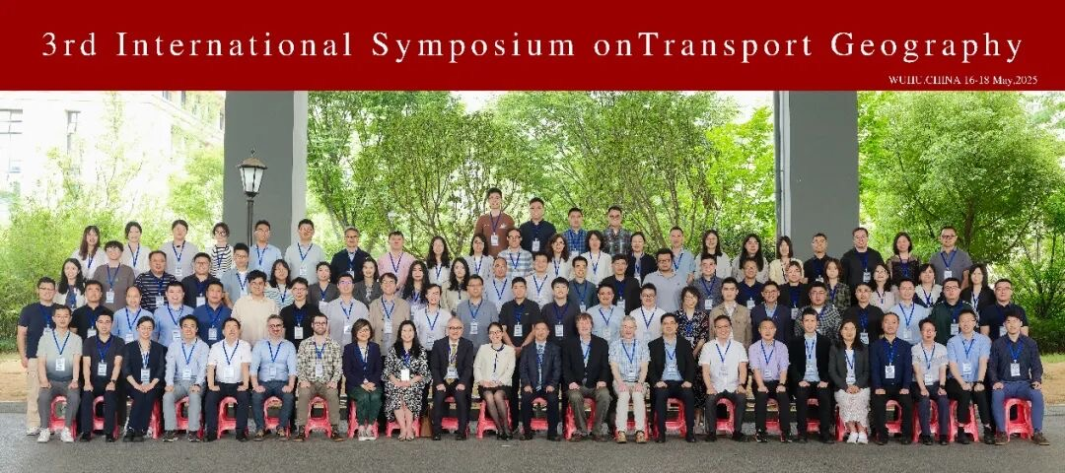

Another highlight is the initiative of designating the Journal of Transport Geography as the official journal of the Commission in collaboration with the publisher Elsevier who has in principle expressed support for such association including promote IGU’s conference alongside their other activities; the official outlet for conference papers; in return IGU would provide support to the strategic activities and aspirations of the journal.

Publications

- In 2025, a total of 12 newsletters was communicated to the commission members via Mailerlite about the commission activities.
- Book projects: “Historical Transport Networks Europe 1500-Present” and “Geographies of high-speed rail” were two book projects associated with the two sessions at IGC Dublin 2024.
- Special issues: A thematic session in IGC Dublin were approved for a special issue on “Cities”, entitled “Sustainable Transit-Oriented Development (STOD): New perspectives and Advances”. Five papers have already been published so far with the special issue expected to be completed in early 2026.
- Jurkowski, W. (2025). Barriers and Opportunities for Transit-Oriented Development in Poland from a Socio-Psychological Perspective. Cities, 165, 106202.
- Knowles, R. D., & Nikitas, A. (2025). Transit-oriented development versus car-dependent development: The importance of high frequency transit services and prior investment in transit. Cities, 166, 106231.
- Li, Y., & Gu, K. (2025). Urban morphology and transit-oriented development (TOD): Planning and managing urban change in New Zealand. Cities, 167, 106407.
- Taczanowski, J., Kołoś, A., & Fiedeń, Ł. (2026). A monument to socialist industrialisation or a tool for creating urban development? Rehabilitation of former industrial tram lines (FITL) in Central-Eastern Europe after socialist industrialisation in the context of transit oriented development. Cities, 170, 106673.
- Cissé, N. A., Renne, J. L., & L'Hostis, A. (2026). Rosa Parks railway station area in Paris as an Equitable Transit-oriented development. Cities, 170, 106662.
In addition, a further special issue on Journal of Transport Geography, ‘Rethinking Transit-Oriented Development: Territorial Restructuring, Intermodality and Governance’, derives from two special sessions organised by the commission at the Royal Geographical Society Annual Congress 2025 in Birmingham. The call for papers for this special issue opened on 1 December 2025 and will close on 31 May 2026, allowing for wider participation from scholars whose work is directly relevant to the topic.

- Communication tools:
Website: https://igu-transport.org/
LinkedIn Account: https://www.linkedin.com/company/105801783/admin/notifications/all/
YouTube channel: http://www.youtube.com/@TGCommissionIGU

Popularization

The commission steering committee made a major contribution to interdisciplinary and cross-continental dialogue in promoting research frontiers and the innovative development of transport geography. Through interdisciplinary dialogue organised around four thematic sessions - Theory, Sector, Inter-discipline and Prospect, three Steering Committee members, including Dr Chia-Lin CHEN (Chair), Professor Frédéric DOBRUSZKES (Honorary Member and Former Chair), Professor Andrew R. GOETZ (Treasurer and Honorary Member), respectively contributed their viewpoints on “Rethinking the relationship between the transport geography and spatial planning”, “The development of transport geography in China from a European scholar’s perspective”, and “The role of geography in transport research” alongside leading and emerging international and Chinese scholars.

In addition to advancing interdisciplinary research, this publication also sheds light on pedagogical development in geography and related disciplines. The publication is published in Chinese.

The full citation
WANG Jiaoe, CAO Jason, CAO Weidong, CHEN Chia-Lin, DOBRUSZKES Frédéric, DUCRUET César, FU Xiao, GOETZ Andrew R., GUO Jianke, HUANG Jie, LI Yuanjun, LOO Becky P. Y., SCHWANEN Tim, WANG Lei, YANG Dong, ZHANG Anming, ZONG Huiming, WU Qitao. Transport geography: An interdisciplinary and cross-continent dialogue. Geographical Research, 2025.44(7): 1733-1754. DOI: 10.11821/dlyj020250562

Archival contributions

In 2025, the Commission has shared two online workshop events with the IGU Secretary-General and the assistant Secretary General for encouraging wider participations via the IGU website.

Archiving and dissemination: The Commission systematically archives key activities and outputs, including online workshop recordings, event programmes and activities, calls for travel grant applications, award and event announcements, publications, and annual reports, ensuring transparency and long-term accessibility.

Digital accessibility and inclusion: Materials are disseminated through the Commission’s email communication via Mailerlite, Website, YouTube channel, and a professional social media platform (LinkedIn). The commission ensures open access, Global South engagement, and participation by early-career researchers across different regions and time zones.

Continuity and institutional memory: The activity archive strengthens a continuity of our mission, supports leadership transitions, and enhances the visibility and impact of the Commission’s work within the IGU and the wider transport geography research community.

Finance Report
This financial report covers the period from January 2024 to November 2025. During this period, Commission funds were used exclusively to support dissemination and Commission activities, including the subscription and maintenance of the Commission website and the award of two travel grants to enable early-career researchers Katherine Agong (University of the West Indies, Trinidad and Tobago) and Dmitry Boyko (Leibniz Universität Hannover, Germany) to attend the 2024 International Geographical Congress (IGC) in Dublin.
Date | Activity | Amount | Balance
Jan 2024 | Start | -- | $5799.21
Feb 2024 | Incoming transfer from IGU (minus $15 wire fee) | +$1485.00 | $7284.31 (includes interest)
Aug 2024 | Two travel grant awards | -$1600.00 | $5684.66
Sep 2024 | WordPress website account annual payments for 2022,2023, 2024 | -$423.84 | $5260.82
Jul 2025 | Incoming transfer from IGU | +$1500.00 | $6761.25
Jul 2025 | WordPress website account annual payment for 2025 | -$163.08 | $6598.17
Nov 2025 | Current balance | -- | $6598. 44

Dr Chia-Lin CHEN
Chair, IGU Commission on Transport and Geography

Professor Pengjun ZHAO
Vice-Chair

Dr Dong Liu
Secretary

December 2025

