International Regional Congress Istanbul, 17-21 August 2026
IGU Commission on Transport and Geography
Travel Grant Program

The International Geographical Union (IGU) Commission on Transport and Geography announces the availability of travel grants to help defray the costs of participation in the next International Regional Conference, 17-21 August 2026 in Istanbul, Turkey.
Please note that, due to limited availability of funds, our Travel Grants provide only a partial contribution to registration, transport and accommodation.
In selecting applicants to receive awards, preference will be given to:
- Scholars based in countries classified by the World Bank as low-income or lower-middle-income economies at the time of travel. This country classification is based on the applicant’s affiliation rather than the country of origin.
- Young or emerging scholars (PhD candidates and up to five years after receiving the PhD Award).
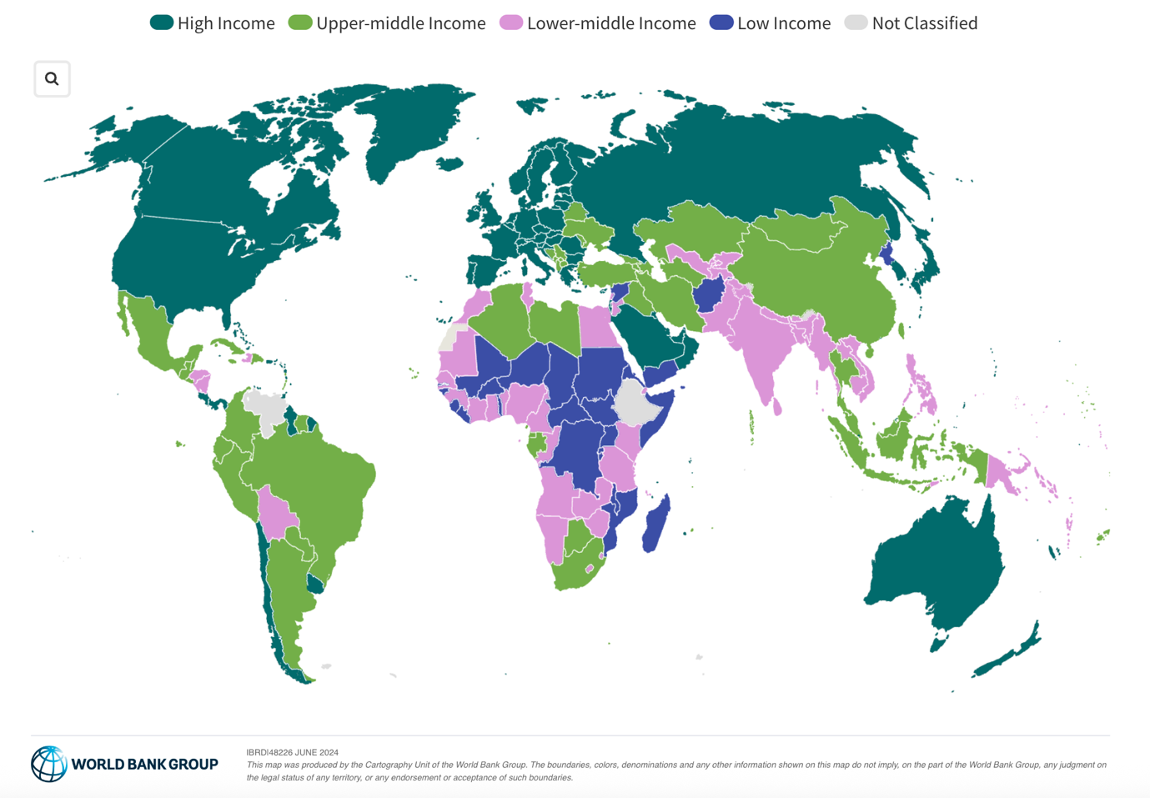
Source: World Bank Blogs

Considering the country condition and the career stage, three schemes of travel grants are listed below.
- Early stage, same macro-region or distance <4,000 km: $800
- Early stage, other macro-region or distance >4,000 km: $1000
- Low-income and Low-Middle-income countries: $1600
In total, the best two/three applications will be awarded to successful candidates, regardless of the schemes.

Because the funds available for this awards program are limited, all applicants will be required to find the balance of the costs of participation; applications for 100% support cannot be funded.
Application:
Applications should be accompanied by:
- The form (see page 3), including a written statement
- The abstract of your paper
- A proof of submission of the abstract to the special session’s conveners.

All documents must be submitted directly to Dr Dong Liu (Commission’s Secretary) – dongliu@cuhk.edu.cn

Timeline:
Completed applications (including endorsement letters) must be sent by the 28th February 2026.
Applicants will then be notified of the outcome of their requests by 14th March.
Awards are paid to successful applicants in cash on arrival for the conference in Istanbul in US$ dollars.

Direct any questions regarding IGU Transport and Geography Commission’s Travel Grant applications to dongliu@cuhk.edu.cn

Please see the form next page.

Istanbul 2026 Travel Grant Application
Please print clearly
1. Individual submitting this application

Last Name______________________ First Name ______________________________
Nationality______________________ Date of Birth _____________________________
Mailing Address_________________________________________________________
______________________________________________________________________
______________________________________________________________________
Telephone ______________________
E-mail________________________________
Current Position and Employer:
______________________________________________________________________
______________________________________________________________________
Highest Academic Qualification Earned ______________Year obtained_____________
Title of paper to be presented______________________________________________
______________________________________________________________________
______________________________________________________________________
Endorsement Letter attached from __________________________________________
Position _____________________________________E-mail ___________________

2. Participation in the Istanbul 2026 IRC Conference and Related Events
In addition, please provide a written statement (one-page maximum length) describing your plans for participating in the 2026 IRC Conference in Istanbul, including the title of the presentation you intend to give, the meetings of IGU Commissions and Task Forces in which you will participate, if you intend to take part in any pre- or post-congress excursions, etc. Include a brief statement of the benefits you expect to realize from your participation in the congress.

Details regarding the conference are available at https://www.irc2026.org/en/default.asp

World Bank Group classifies the world’s economies into four income groups: low, lower-middle, upper-middle, and high. These classifications, updated each year on July 1, are based on the previous year’s Gross National Income (GNI) per capita.

